The Magic Mountain Abstract Template
Thomas Mann¹, Hans Castrop², Clawdia Chauchart², Ludovico Selttembrini^{2,3}, Leo Naphta³
1 ETH Zurich, Thomas Mann Archives, Switzerland, tma@library.ethz.ch; 2 Sanatorium Berghof, Switzerland; 3 Haus Lukacek, Switzerland
„An unassuming young man was traveling, in midsummer, from his native city of Hamburg to Davos-Platz in the Canton of the Grisons, on a three weeks’ visit.
[...] At Rorschach, in Swiss territory, you take train again, but only as far as Landquart, a small Alpine station, where you have to change. Here, after a long and windy wait in a spot devoid of charm, you mount a narrow-gauge train; and as the small but very powerful engine gets under way, there begins the thrilling part of the journey, a steep and steady climb that seems never to come to an end. For the station of Landquart lies at relatively low altitude, but now the wild and rocky route pushes grimly onward into the Alps themselves.
[...] The train wound in curves along the narrow pass; he could see the front carriages and the laboring engine vomiting great masses of brown, black, and greenish smoke, that floated away. Water roared in the abysses on the right; on the left, among rocks, dark fir trees aspired toward a stone-gray sky. The train passed through pitch-black tunnels, and when daylight came again it showed wide chasms, with villages nestled in their depths. Then the pass closed in again; they wound along narrow defiles, with traces of snow in chinks and crannies. There were halts at wretched little shanties of stations; also at more important ones, which the train left in the opposite direction, making one lose the points of the compass. A magnificent succession of vistas opened before the awed eye, of the solemn, phantasmagorical world of towering peaks, into which their route wove and wormed itself: vistas that appeared and disappeared with each new winding of the path. [...] He perceived that they had stopped climbing. The top of the col was reached; the train rolled smoothly along the level valley floor.
[...] A lake was visible in the distant landscape, its water gray, its shores covered with black fir forests that climbed the surrounding heights, thinned out, and gave place to bare, mist-wreathed rock. They stopped at a small station. Hans Castorp heard the name called out: it was ‚Davos-Dorf‘.”
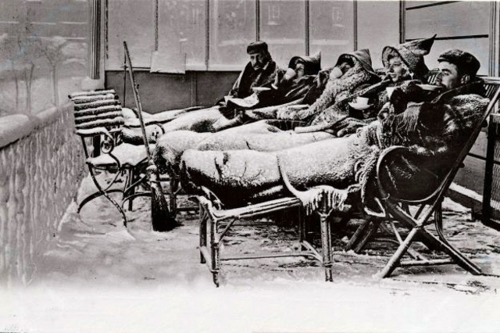
Fig. 1 Just what the doctor ordered: TB patients spent long hours in the fresh air.
(Picture taken from: Simon Bradley, The dark side of Davos’s magic mountain. www.swissinfo.ch)

Formatting instructions for abstract submission

Total maximum length | 1 A4 page
Maximum number  of figures | 1
Abstract title | do not exceed two lines
Authors | <given name> <surname>^{<reference to affiliations>}  Underline the presenting author
Affiliations | <reference number> <university/company>, (<institute>), <country>, (<email>)  Email of at least one corresponding author must be given
Abstract text | No restrictions, but to stay within one page total abstract length. Font sizes and type may not be changed (Verdana, exists on PC, Mac and Linux (ttf-mscorefonts-package)).
Figure | Optional, no restrictions, please consider a resolution high enough to recognize the details you refer to. A caption needs to shortly describe the content of the figure. The figure should be referred to in the text. If you have a figure, a caption is mandatory. The total abstract length of one page may not be exceeded even including the figure.
Submission PDF file  naming convention | Delete this instruction page and save your abstract as PDF file following our naming convention:  schatzalp_talk_<session number>_<surname of contact person>.pdf  schatzalp_poster_<session number>_<surname of contact person>.pdf  schatzalp_nopreference_<session number>_<surname of contact person>.pdf  schatzalp_fellowship_<surname>.pdf  e.g. schatzalp_poster_3_wiemer.pdf  Sessions:  1. Discriminating human-made and natural earthquakes  2. Social aspects of induced seismicity  3. Induced seismicity from gas extraction and post-extraction reuse  4. The Pohang M5.4 earthquake  5. Case studies: geothermal / mining / dams / others  6. Advances in monitoring induced seismicity  7. Modelling induced seismicity  8. Physics of induced earthquakes  9. Laboratory and deep underground lab experiments

You would help us a lot if you stick to this formats.

Thanks in advance and looking forward to seeing you on “The Magic Mountain”,
Stefan, Toni, Barbara

