The PSHA Abstract Template
S. Wiemer¹, D. Giardini², F. Haslinger¹, L. Danciu¹
1 ETH Zurich, Swiss Seismological Service, Switzerland, s.wiemer@sed.ethz.ch; 2 ETH Zurich, Seismology and Geodynamics, Switzerland
Please consider the instructions on the next page.
This scientific workshop brings together about 100 to 150 leading experts on Probabilistic Seismic Hazard Assessment (PSHA) from around the globe to discuss the current state of practice as well as future directions. The workshop will adopt a holistic point of view (i.e. interdisciplinary, multiple spatial- and temporal scales), critically reflecting all elements of modern PSHA.
Distinguished keynote speakers will introduce a range of topics, but we also call for solicited contributions (oral and poster). We will allocate sufficient time for discussions and networking, and the beautiful castle in Lenzburg offers a unique setting.
Revisiting past and ongoing site-specific projects on local, national or transnational scales, we strive to draw conclusions for future PSHA projects. We will also reflect on emerging challenges, such as time-dependence, earthquake interactions, anthropogenic seismicity, model validation, simulation based PSHA, communication of hazard results and procedural requirements for ensuring robustness, especially in the context of PSHA for critical facilities. On day three, we will focus specifically on the needs of community and harmonization projects, such as the next-generation European PSHA.
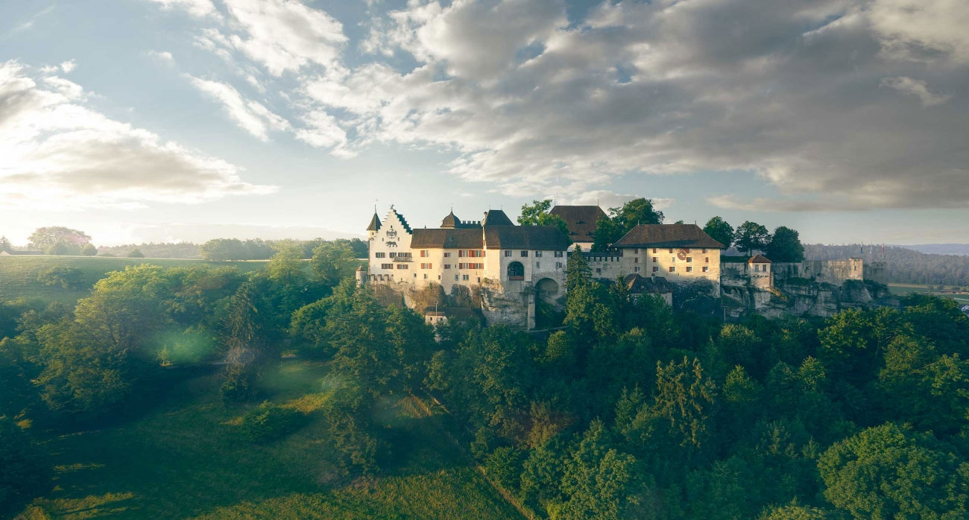
Fig. 1 Not only counts and dukes used to call Lenzburg Castle their home, also a German poet and an American adventurer once lived at this historically significant site. The castle has always been of great relevance to the region and lived through many political uprisings dated as far back as to the 12th century.

Instructions
Total maximum length | 1 A4 page incl. figure
Maximum number  of figures | 1
Abstract title | Do not exceed two lines
Authors | <given name> <surname>^{<reference to affiliations>}  Underline the presenting author
Affiliations | <reference number> <university/company>, (<institute>), <country>, (<email>)  Email of at least one corresponding author must be given
Abstract text | Font sizes and type should not be changed (Verdana, exists on PC, Mac and Linux (ttf-mscorefonts-package))
Figure | Please consider a resolution high enough to recognize the details you refer to. Insert a caption shortly describing the content of the figure. The figure has to be mentioned in the text.
PDF naming | Delete this instruction page and save your abstract as PDF file following our naming convention:  PSHA_talk_<session number>_<surname of contact person>.pdf  PSHA_poster_<session number>_<surname of contact person>.pdf  PSHA_nopreference_<session number>_<surname of contact person>.pdf  PSHA_fellowship_<surname of applicant>.pdf  e.g. PSHA_poster_3_wiemer.pdf  Sessions:  1 Lessons Learned  2 Seismogenic Source Modelling  3 Ground Motion Predictions  4 Site Characterisation  5 Hazard Integration  6 Coordinating European Efforts

